**Lab 2**

1. Use contrast stretching on the image.

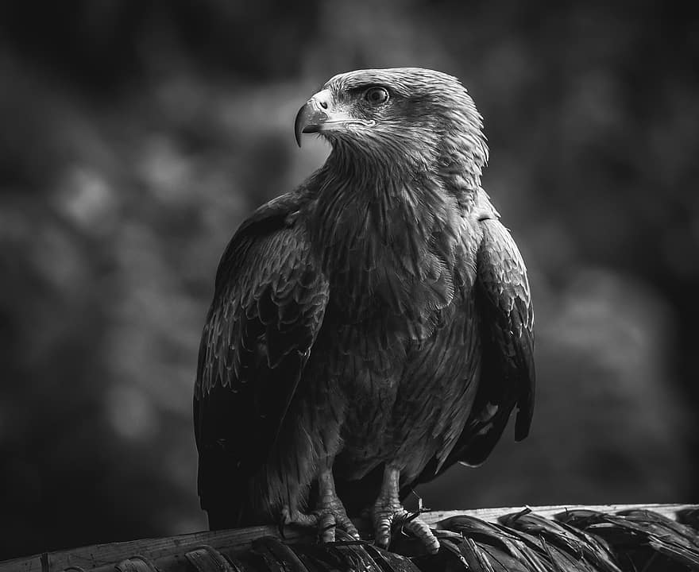

1. Apply bit plane slicing on the image.

1. Change the contrast of the image using Logarithmic Transformation and Power-law Transformation.

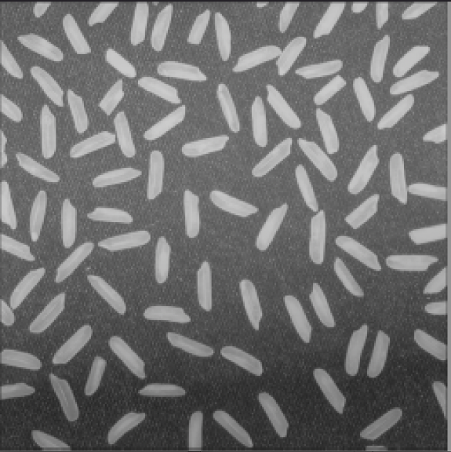

1. Adjust the histogram of the following image to match the reference image using histogram matching. Show the histogram of original, reference, and output images.

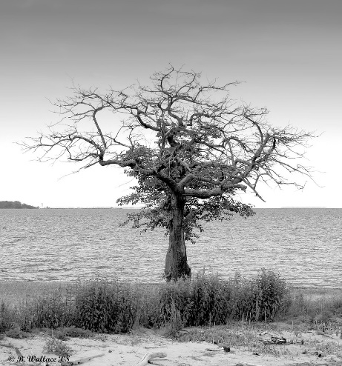 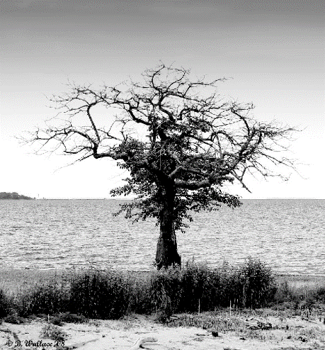

1. Change the contrast of the image using histogram equalization. Show the histogram of both input and output images.

